**MESD LMS Documentation - View/print/download Students Academics reports**

**Purpose**

Allow school heads to view and download student academic reports. The following capabilities were added to facilitate this:

* report/performance:view
* moodle/course:view
* moodle/course:viewparticipants
* moodle/course:viewhiddencourses
* gradereport/grader:view
* moodle/grade:viewall

**Usage**

1. Log in as the **School Head.**
2. Navigate to a course.
   1. 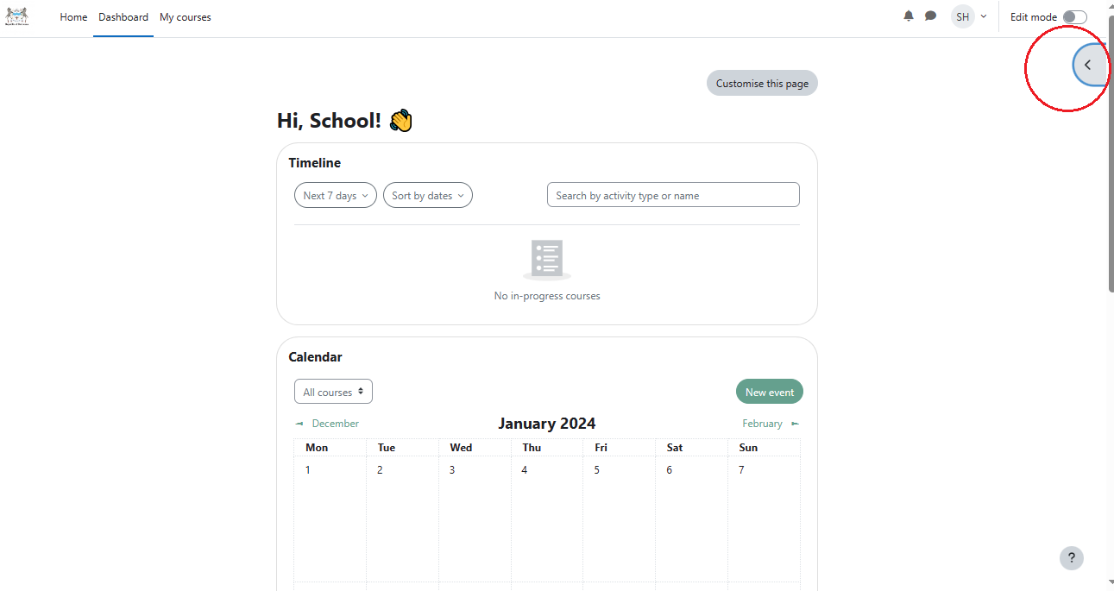 Open your block drawer.

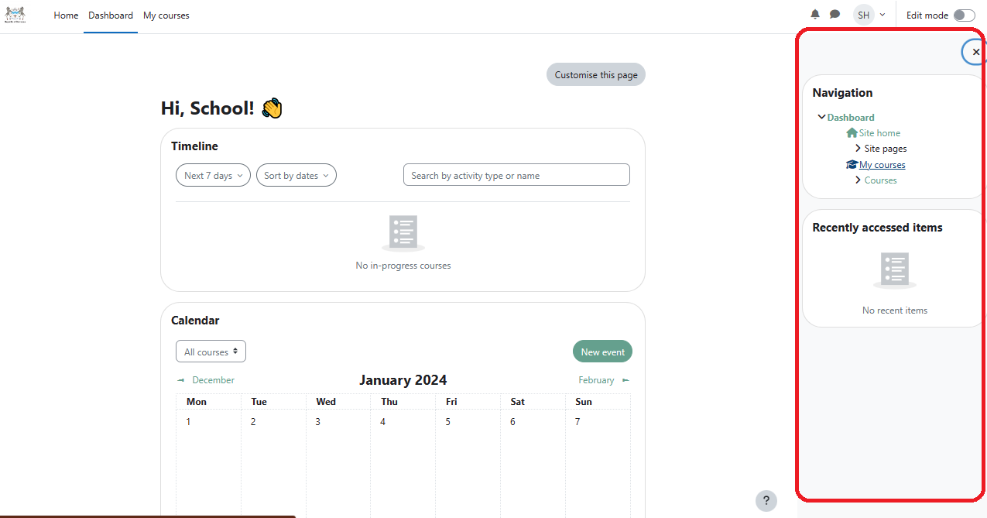

* 1. Double click on **Courses.**
  2. Select a subject/course.

1. On the course administration menu navigate to **Grades**.

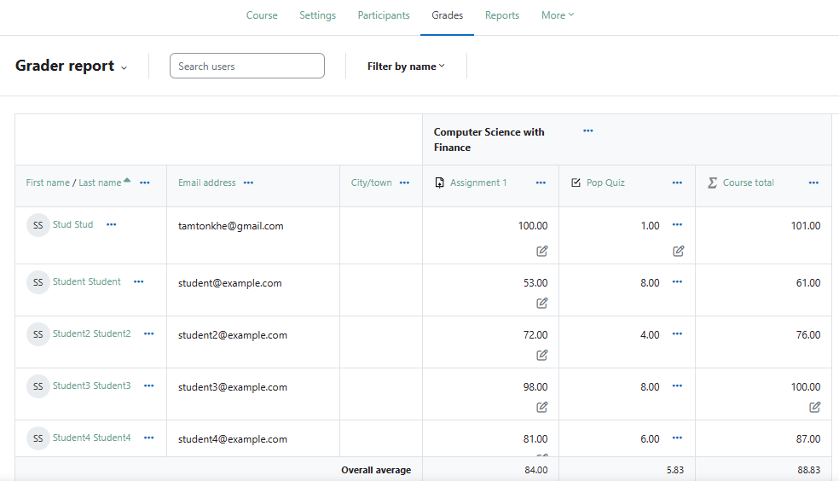

Results for every graded assessment will be displayed here along with the class average for each assessment and average for course total.

1. 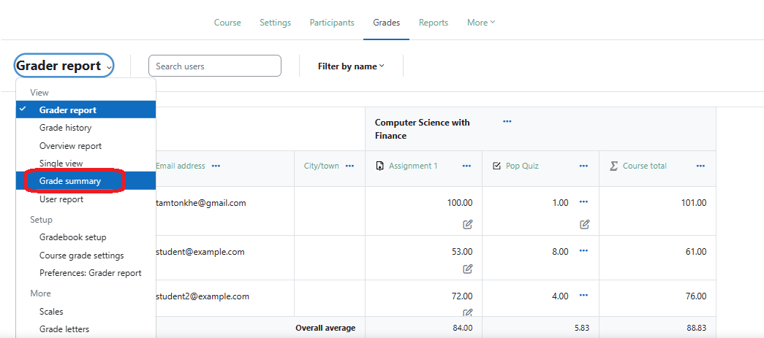Click on the **Grader report** dropdown menu and click on **Grade summary** to view the grade summary of the entire class.

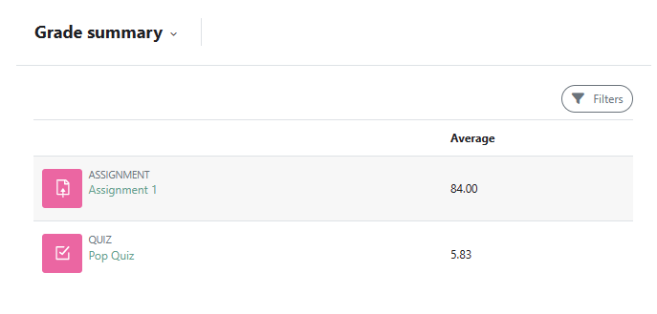

1. Click on the **Grader report** dropdown menu and click on **User report** to view individual records. You need to search for a user first. Below I’m searching for Student3 for example:

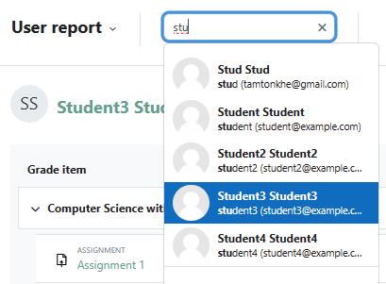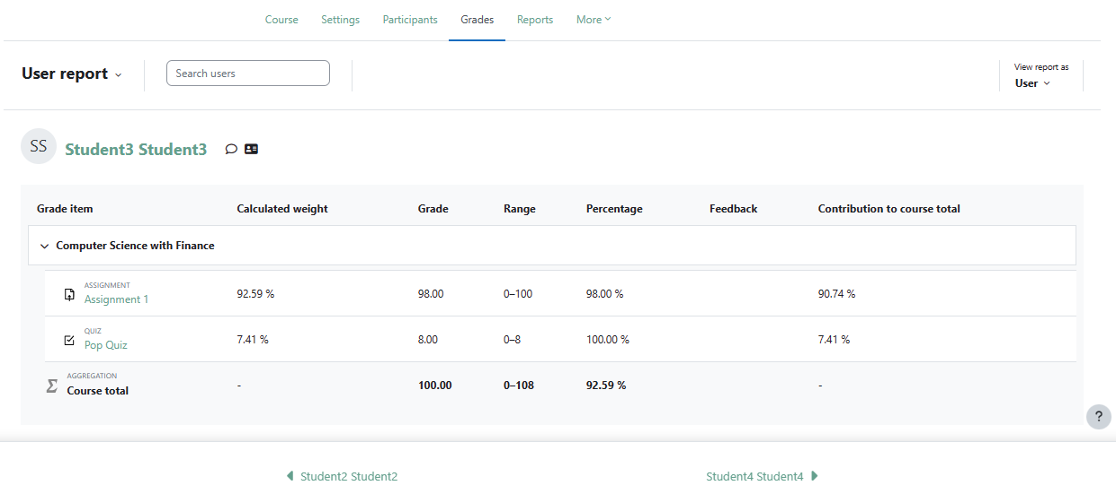

There is no way to download individual records but class academic records can be downloaded.

1. To download class academic records click on the **Report** dropdown menu and scroll to **Export** under **View**.

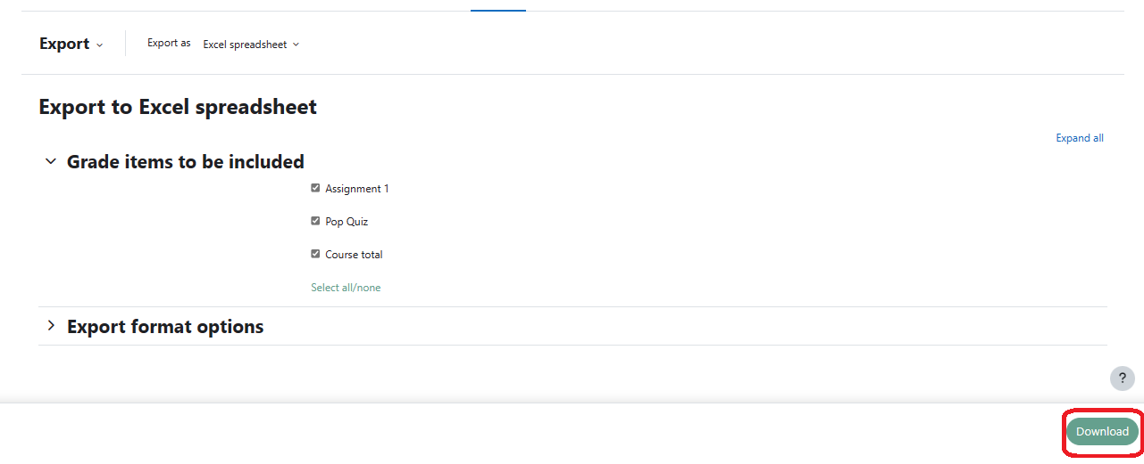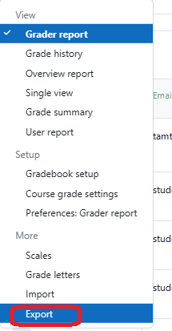

Select the file format, select the assignment results and course totals you’d like to download and click **Download** to get the data.